The activities of the Burnett County Historical Society are supported through
membership dues,
donations,
grants,
programming and events,
fundraisers.

Support is also received from Burnett County which owns the land.

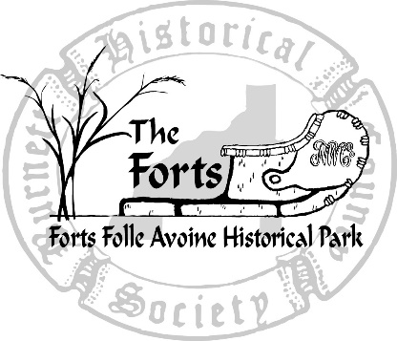

If you wish to donate artifacts or documents related to Burnett County, its businesses, schools, churches, land and people, please contact us.

Burnett County Historical Society
Forts Folle Avoine Historical Park
8500 County Rd U
Danbury, WI 54830

715-866-8890

Forts Folle Avoine
Historical Park
is an 80-acre park located on the banks of the Yellow River, 3 miles west of Wisconsin Highway 35 on County Road U.

Folle Avoine (faal a-vwon) means "crazy oats," the voyageurs' term for wild rice.

The Burnet County Historical Society operates the historical park as a non-profit educational facility.

The park includes:
Visitors Center
Two reconstructed fur trading posts and Woodland Indian Village
History Research library
Amphitheater
Karlsborg School
Swedish Kiosk
Logging Museum
Blacksmith Shop
Gardens
Scenic trails
Primitive camping areas for events

FAHP is open to the public from Memorial Day Weekend through Labor Day Weekend, Wednesdays through Sundays, 10:00 AM to 4:00 PM.

For more information, including our
off-season schedule and dates of special events, please check www.TheForts.org.

Like us on Facebook!

Support the Forts!
Burnett County
Historical Society

The Burnett County Historical Society researches, preserves, and teaches the history of Burnett County, WI.
In support of its mission, BCHS:
- Manages Forts Folle Avoine Historical Park with Living History tours of Fur Trade Posts and Ojibwe Indian Village
- Provides educational programs for schools
- Creates Exhibits that interpret Burnett County History
- Operates a Research Library
- Stores historical records and artifacts from Burnett County
- Produces publications related to Burnett County history
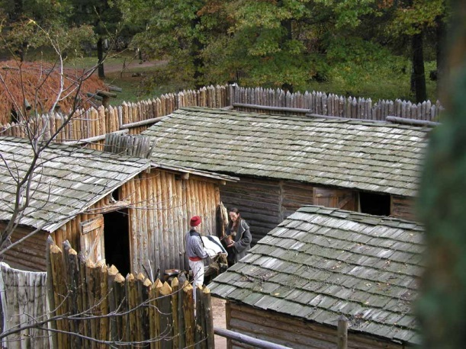

We invite you to join the Burnett County Historical Society and financially support our mission!

Memberships include these benefits:
Unlimited General Admission including
Tours and the Rendezvous.
Free or reduced fee for many programs
10% discount on Gift Shop purchases
BCHS Newsletter - three per year

Adult members have one vote each at the Annual Membership meeting.

Memberships are Tax Deductible to the extent allowable by law.

2018 General Memberships

Family - $50.00
two adults and up to four children 6-17
(children 5 and under are free)
Family Plus - $75.00
All the benefits of Family membership plus 4 additional one-time General Admission tickets to share with others
Couples - $50.00
two adults and 2 additional one-time General Admission tickets to share
Individual - $25.00
one adult
Seniors/College Students/Military (active and
veterans) - $20.00
one adult

2018 Supporting Memberships

Explorer - $120.00
two adults and 8 additional one-time General Admission tickets to share
Voyageur - $250.00
two adults and 10 additional one-time General Admission tickets to share
Company Partner - $500.00-$1,000.00
two adults and 12 additional one-time General Admission tickets to share

Burnett County Historical Society 2018 Membership Application Form

Membership: ____ New ____ Renewal

Name1:____________________________________________________________________
Name2:____________________________________________________________________
Primary Address:_____________________________________________________________
City: _________________________________________ State: _____ Zip:_______________
Phone:___________________________email:_____________________________________

Check one:

____ Family - $50.00 ____ Senior ____ College Student ____ Military - $20.00

____ Family Plus - $75.00 ____ Explorer - $120.00

____ Couples - $50.00 ____ Voyageur - $250.00

____ Individual - $25.00 ____ Company Partner - $500.00-$1,000.00

I’m interested in being a volunteer at The Forts: ________

ADDITIONAL DONATION to support school programming: $________________________

Payment (check/cash): Amount of Check/Cash Enclosed: $________________________
Pay by credit card: Visa/Mastercard/Discover #________________________________
Exp. Date ________

Print the credit card holder’s name: _____________________________________________

Signature of credit card holder: ________________________________________________

Mail to: Burnett County Historical Society
8500 County Rd U
Danbury, WI 54830

